Module 4 (Set 1 code)
How to train an ANN

1) The main difference between the two, is that a Perceptron takes that binary response (like a classification result) and computes an error used to update the weights, whereas an Adaline uses a continous response value to update the weights (so before the binarized output is produced).

2) In order to prevent the model from executing infinite training steps we can set the maximum epochs value that passes over the training data set or we can set a threshold for the number of tolerated misclassification.

Module 4 (Set 2 code)

1) The optimum no of Epochs is 3 because after that the change in training cost is very less as seen from the elbow method.

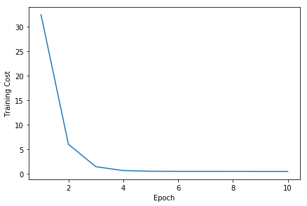

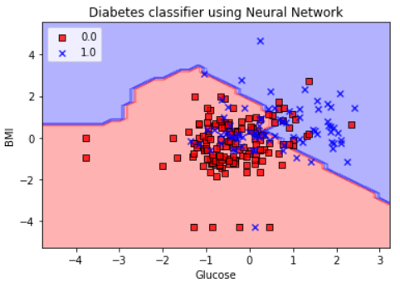
2)

From the output plot we can see that the classifier is not a better classifier as the points are not classified properly.

3) We’ll get an error message, as we are doing incremental training previously our model was trained with only one hidden layer if we change the number of hidden layers our model will trace back as it will consider previously trained model with only one hidden layer.

4) We can fix the problem in the prior question by setting model_dir=None
classifier = tf.estimator.DNNClassifier(feature_columns=feature_columns,
hidden_units=[5,10,5], n_classes=2, model_dir= None)

